# Introduction

For people who have difficulty using typical input devices like computer mice or the thumbsticks on video game controllers, joysticks can provide a more accessible option. Commercial options can be expensive, difficult to source, or require too much force or range of motion. The goal of this project is to develop a cost-effective, open source, customizable lineup of joysticks, using easy to source components. These joysticks will be designed for Maker assembly with all the digital files necessary to customize key components easily.

The Adafruit Mini Analog Joystick (<https://www.adafruit.com/product/3102>) is a generic arcade style, analog joystick. The goal of this joystick is to have a slightly higher force, higher movement joystick with multiple topper options. Another goal with this design is to have modularly added buttons, as this joystick mechanism has a tall profile, making it difficult to reach buttons placed nearby.

**Note:** A CAD model of this joystick can be found at the following link: <https://www.digikey.ca/en/products/detail/adafruit-industries-llc/3102/6152821>

## Who

Who will be using the device?

* The device is intended for use by a single user at a time. However, through modular toppers, should be able to be used by different users.
* People unable to use a conventional game controller.
* OTs and other professionals to become familiar with the joystick.

Who will be affected by the device?

* The user.

## What

What must the device do?

* The device is intended to be USB compatible with PCs.
* The device is intended to be USB or Analog compatible with the XAC.
* The device is NOT intended to be used to control a mobility device.

What needs must the device serve?

* Users with low thumb/finger dexterity
* Users with the following possible points of access:
  + Hand
  + Forearm
  + Elbow
  + Chin
  + Foot

## Why

Why will the device be used?

* To enable or improve a user’s ability to play video games

## Where

Where will the device be used?

* In a home.
  + At a desk
  + At a wheelchair
  + On a bed
  + On a couch
* In a physical rehab setting.

## When

When will the device be used?

* When using a computer or other compatible gaming unit (Xbox).
* When testing out different gaming set-ups.

# Functional Properties

## Goals

|  |  |
| --- | --- |
| G01 | Achieve a material cost of less than $80 CAD. |
| G02 | Maker manufacturable in quantities of one. |
| G03 | The use of support material in 3d printed components should be minimized. |
| G04 | The number of different filament types should be minimized. |

## Functional Requirements

|  |  |
| --- | --- |
|  | The joystick design shall consist of a variant with USB output and a variant with XAC-compatible analog output. |
|  | The joystick shall be usable from a minimum distance of 1.5m away. |
|  | The joysticks shall be compatible with the Xbox Adaptive Controller. |
|  | Joysticks shall be PC compatible. |
|  | The joystick shall denote use orientation. |
|  | The joystick shall have a range of easily interchangeable toppers. |
|  | Toppers shall not interfere with the regular physical motion of the joystick. |
|  | Toppers shall have a secure connection to the joystick. |
|  | The joystick shall be designed to be used by either hand. |
|  | Joystick shall remain stable when in use. |
|  | The housing shall protect internal components from outside sources. |
|  | Joystick designs shall support camera mounting styles. |
|  | Joystick designs shall support hook and loop fastener mounting styles. |
|  | Joystick designs shall support tabletop mounting styles with no fasteners. |

## Non-functional Requirement

|  |  |
| --- | --- |
| NF01 | Documentation should be maintainable with the use of commonly available software. |
| NF02 | Documentation must be available in a digital format. |
| NF03 | Documentation must be printable. |
| NF04 | Documentation, code, and hardware must have appropriate open-source licenses. |

## Constraints

|  |  |
| --- | --- |
| C01 | Joystick must be maker manufacturable. |
| C02 | Joystick mechanisms must be analog by default. |
| C03 | Not for use with mobility devices. |
| C04 | The joystick shall be based on the commercially available Adafruit Mini Analog Joystick. |
| C05 | The Adafruit Mini Analog Joystick has an approximate activation force of 525 grams. |
| C06 | The Adafruit Mini Analog Joystick has an X and Y axis range of ±25° |
| C07 | The Adafruit Mini Analog Joystick has a linearity of ±1% |
| C08 | The Adafruit Mini Analog Joystick has a mechanical lifecycle of 500,000 cycles. |
| C09 | The Adafruit Mini Analog Joystick has an operating temperature range of -10 - 80°C |
| C10 | The Adafruit Mini Analog Joystick has an envelope of 67.4 high x 52.7 mm wide x 52.7 mm deep |
| C11 | 3D printed components shall be printable within a 180x180x180mm print volume. |

# Research

Comparable designs:

[Ultrastik by Ultimarc](https://www.ultimarc.com/arcade-controls/joysticks/ultrastik-360-oval-top-clone/) – SCCR has a 3D printed case available on [Printables](https://www.printables.com/model/268854-ultrastik-analog-joystick-enclosure)

* [Quadstick](https://www.quadstick.com/shop/ultimarc-utrastik-360-enclosure) also sell this in an enclosure. – 149 USD

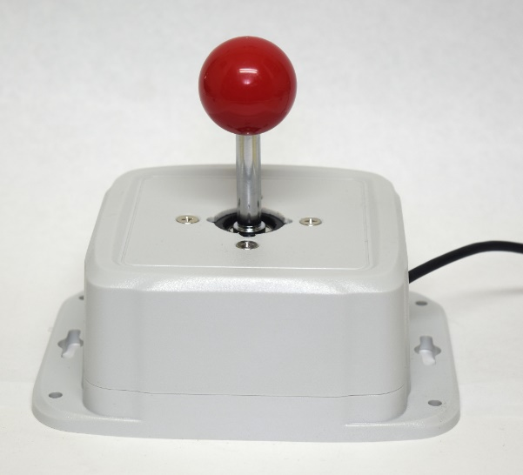

[Warfighters Engaged - Joystix](https://warfighterengaged.org/shop/joystix-l)-L (*Non-USB) – 65 USD

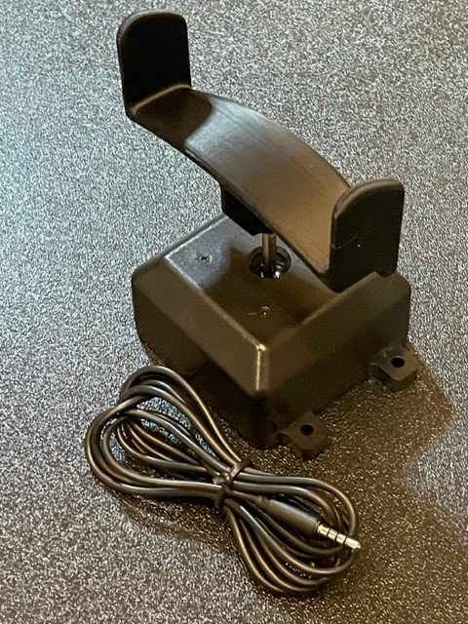

[n-ABLER Joystick by Pretorian](https://www.ergocanada.com/detailed_specification_pages/pretorian_n_abler_joystick.html#specs) – 450 CAD

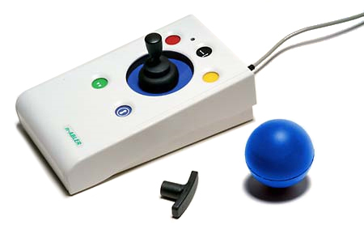

[Slimline Joystick](https://www.bridges-canada.com/products/slimline-joystick?variant=32267864735826) – 444 CAD

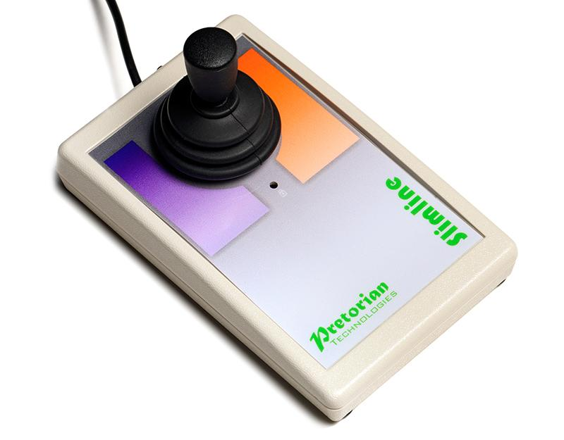

[BJOY Chin](https://www.bridges-canada.com/products/bjoy-chin) – 650 CAD

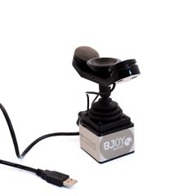

# Mini Analog Joystick - 10K Potentiometers : ID 3102 : $19.95 : Adafruit Industries, Unique & fun DIY electronics and kitsIdeation

**Electrical**

* Protoboard and wires
* Direct to MCU
  + Wires
  + DuPont cables and headers
* Custom PCB

Considerations: Size, difficulty of assembly, MCU does not have mounting holes, will require wired connections regardless due to Joystick configuration, joystick must be screwed in from the top

**CAD Model:** <https://www.digikey.ca/en/products/detail/adafruit-industries-llc/3102/6152821>

**Enclosure**

* Simple box with room for wire routing
* Build out sides, not under the joystick component
* Top snap fit on or uses fasteners
  + Joystick component requires fasteners to mount
    - #4 3/8” work (same as MMC60)

**MCU Mounting**

* Solder to protoboard and then screw down the protoboard
* Built in slot for MCU within enclosure
* 3D printed clamp/cover to hold MCU in place

**Topper Connection**

* Clamping connection
* Set screw connection
* Threaded connection
* Press-fit connection

# Conceptual Design

The main factors to consider with this design are size and cost as the joystick component is already quite large, so increasing the size significantly is undesirable, and the cost of the joystick component is ~$30. Therefore, using the space efficiently and minimizing fasteners (mainly number of different fasteners) is important.

## Enclosure Design

### Concept 1: Simple Square Box

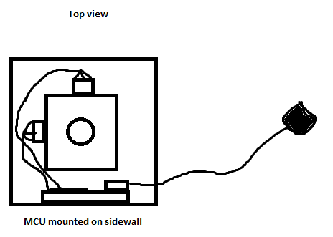

Pros: Simple to design, low profile

Cons: Poor use of space – need space for the potentiometers and MCU, which keeps the joystick corners away from edges of the enclosure, small amount of space to wire the MCU.

### Concept 2: Rectangular

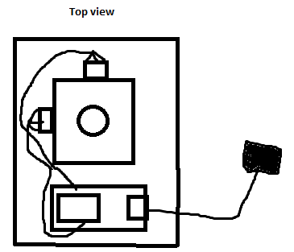

Pros: Simple to design, more room for wiring/mounting the MCU,

Cons: poor use of space, awkward spot for the USB port

### Concept 3: MCU in top Corner

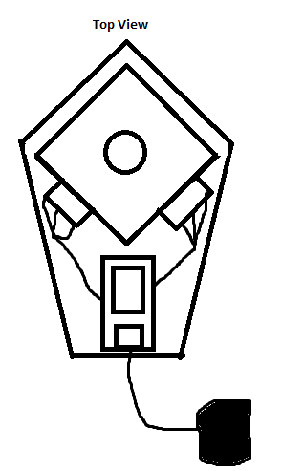

Pros: Efficient use of space, leaves room for MCU wiring, keeps most corners of joystick near an edge for mounting

Cons: unintuitive directions cable exits at an angle

## Joystick Mounting

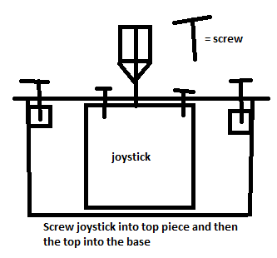

This method would be simpler to do, but would require a larger overall base to leave room for the fasteners to hold the top piece on. It also requires more fasteners. Could be difficult to model due to the top ring of the joystick – would require either replacing the top ring with print, or having a very thin section. Likely more flexible (more connection points spaced out)

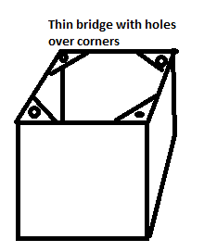

This method allows for a lower profile base and fewer fasteners but would require some type of snap fit or otherwise to hold the top piece on. It also has the potential to be difficult to print depending on the length of bridge required. The section must be thin to fit in between the rubber boot and the joystick box. It may also be difficult to screw into all four holes depending on orientation. Likely more rigid (fewer connection points near the edge)

## MCU Mounting

### Slide-in Slot

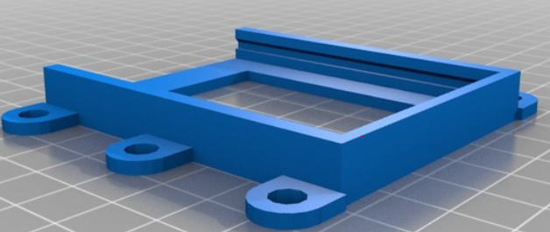

Slot to slide the MCU into and lock in place. Requires some type of retainment method.

### Flexure-based Clamp

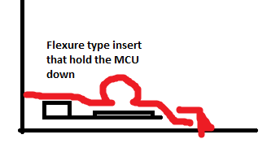

Would require extra space to implement and only relies on pushing the MCU down into the base to hold it in place securely. Likely could wiggle back and forth a bit.

### PCB Mounting Clips

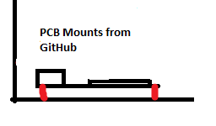

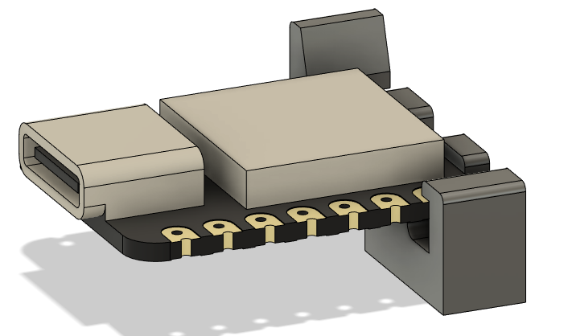

Need to be glued/fastened down in some way. Need to test if it would block the voltage pin.

### Solder to Protoboard A screenshot of a CAD model of the XIAO RP2040 microcontroller mounted to a protoboard with male headers.

Could solder to protoboard and screw down. Would require more space but likely the most secure choice.

### Print in Place Clip

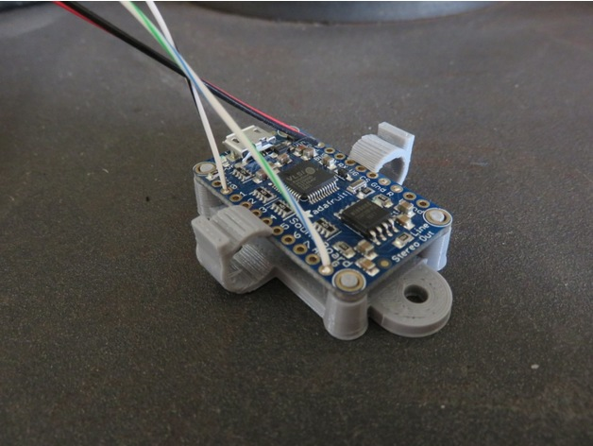

Likely too brittle when printed in PLA (PETG or ABS suggested by designer) <https://www.thingiverse.com/thing:5230779>

# Prototype v0.1 Design

Microcontroller – SEEDStudio Xiao RP2040

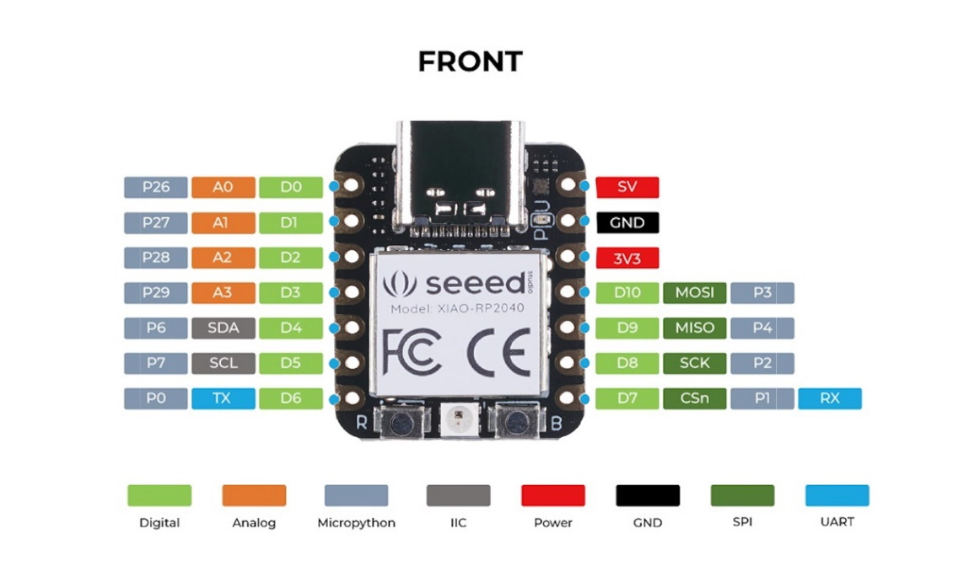

Figure 1 MCU Pinout. <https://wiki.seeedstudio.com/XIAO-RP2040/>

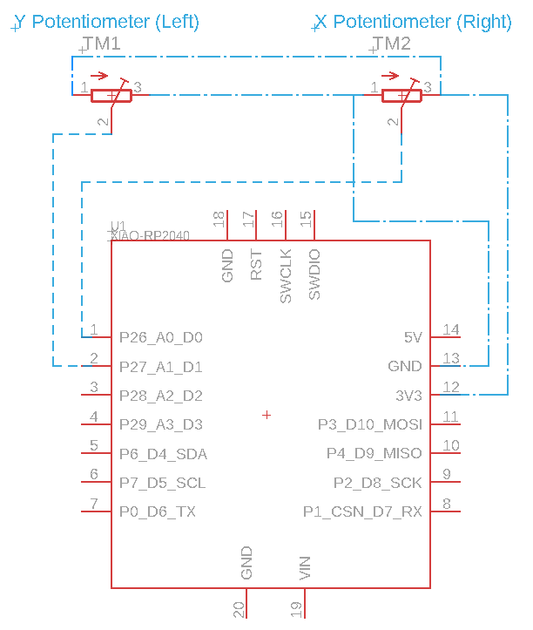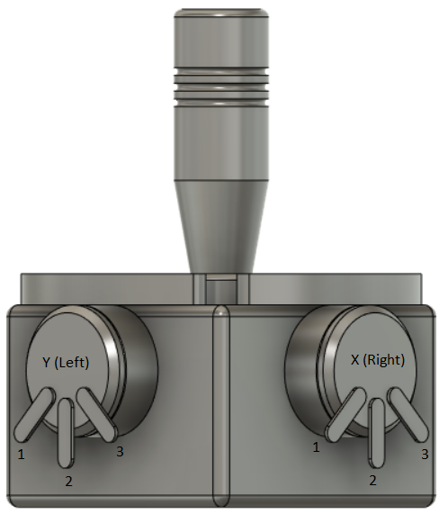

Electrical diagram for wiring the potentiometers to the MCU.

X goes to A0, Y goes to A1

XAC Analog wiring for TRRS:

[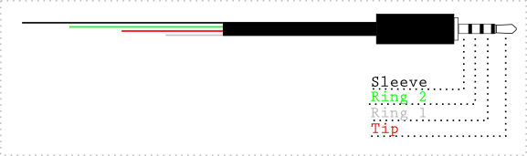](https://www.google.com/url?sa=i&url=https%3A%2F%2Fwww.sparkfun.com%2Fproducts%2F11580&psig=AOvVaw2SZXRFzv8EFveRrgutmxWv&ust=1678992168089000&source=images&cd=vfe&ved=0CBAQjRxqFwoTCOjgj5DL3v0CFQAAAAAdAAAAABAR)

|  |  |
| --- | --- |
| Standard TRRS | Joystick |
| Tip (T) | X |
| Ring 1 (R1) | Y |
| Ring 2 (R2) | G |
| Sleeve (S) | V |

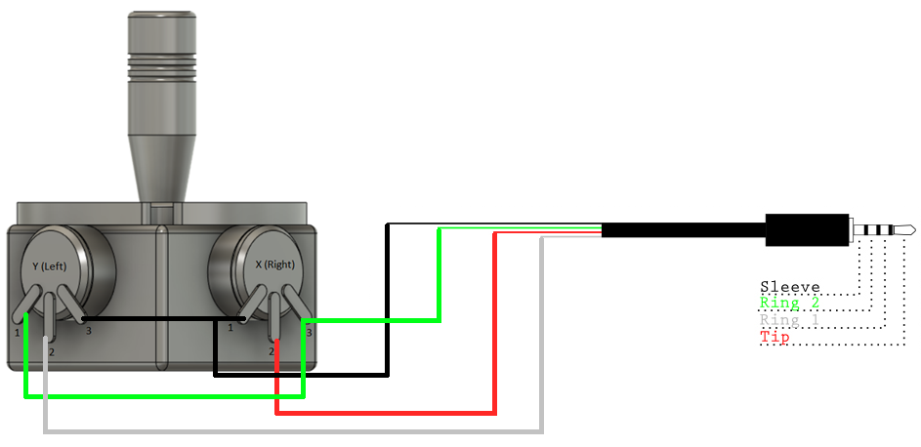

## USB-c Cable Measurements

These measurements are used to define the dimensions of the USB-c cable port through the enclosure.

[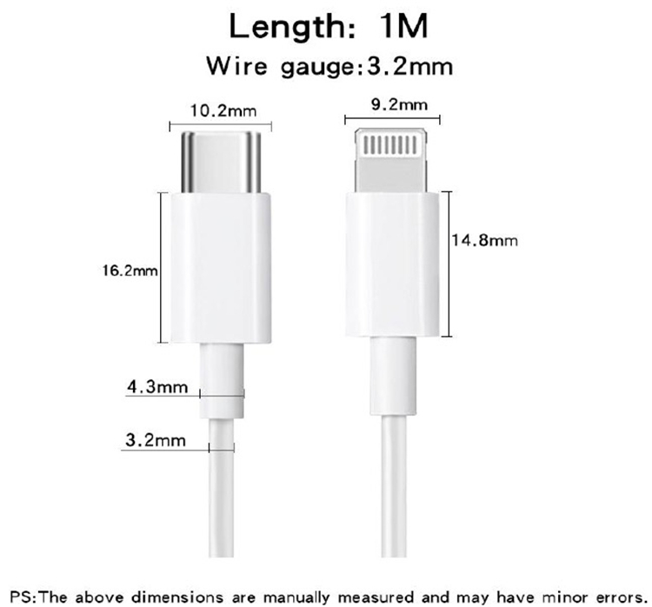](https://www.happy-shopping.ml/products.aspx?cname=iphone+charger+length&cid=67)

[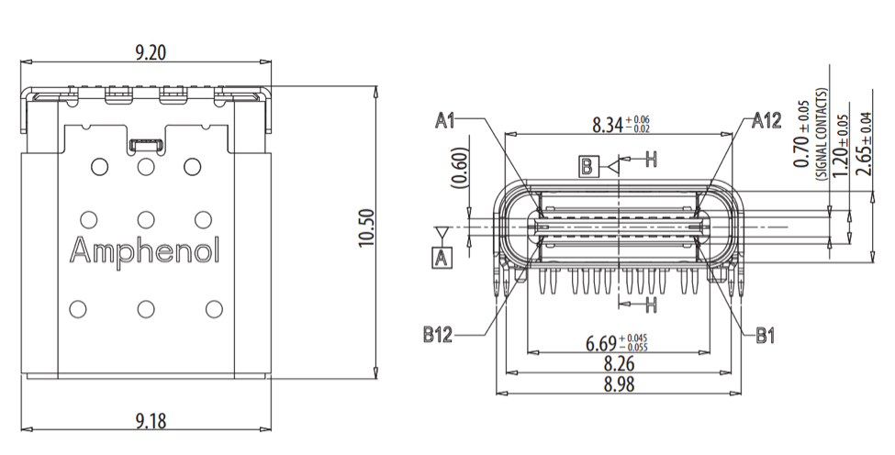](https://www.mouser.com/blog/usb-type-c-explained)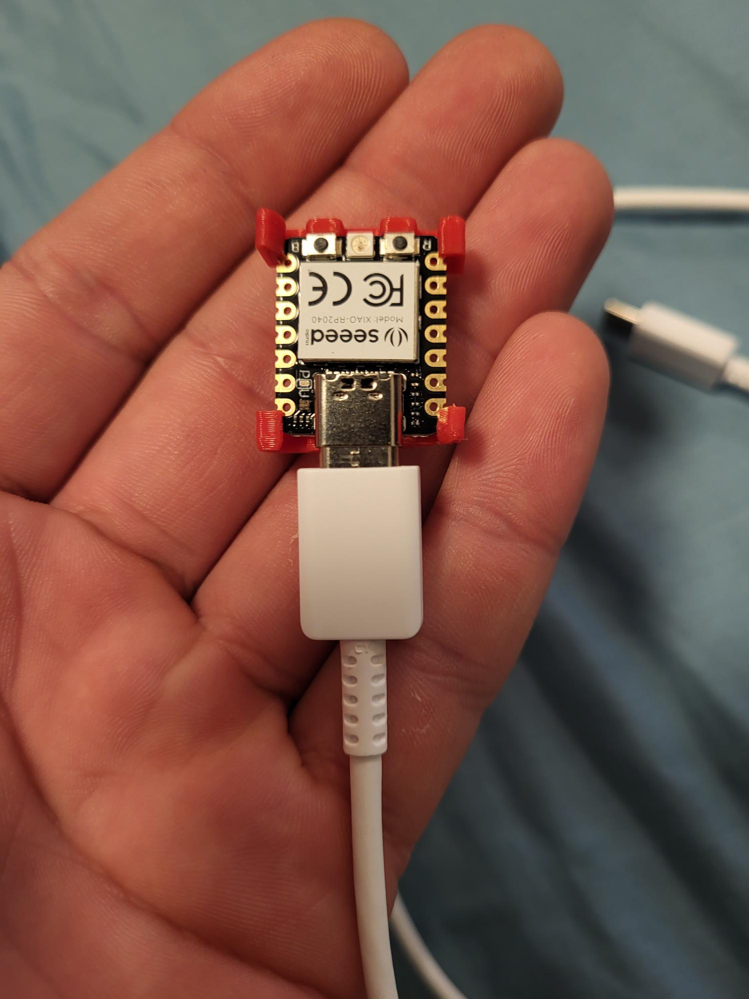

17mm

2.2mm

12mm

## Toppers

### Topper Connection ideas

1. Two halves clamped together
   1. Threads with a split through the cylinder that get snugged up with a nut (all 3D printed)
   2. Quick release style clamp
   3. Hose clamp
2. Friction fit
   1. Tight tolerance
   2. Crush ribs
3. Set screw
4. Threaded (tap and die to joystick handle and topper)

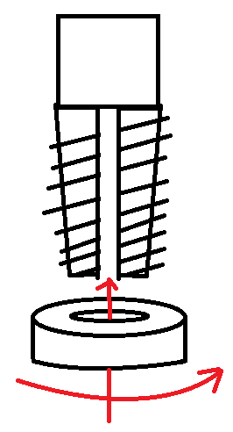[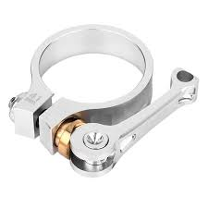](https://i5.walmartimages.com/asr/e15363d1-d237-4b49-822c-782270544d0e_1.b8444f610993dbc2bc3c7ce690b4a671.jpeg?odnHeight=450&odnWidth=450&odnBg=ffffff)

# Prototyping

~~Concept 1: uses the MCU in the top corner arrangement with the bridged corners for joystick mounting and snap fits for the MC- U mount.~~

**Concept 2**: Uses a rectangular shaped box with the joystick screwed into the lid for joystick mounting, and glue-in snap fits for the MCU mount.

#### OFIs

**Enclosure**

* ~~Add a ridge around the connection point between the top and bottom of the enclosure~~
* ~~Move screws for connecting the enclosure together to the bottom~~
* ~~Chamfer all top edges~~
* ~~Increase arrow visibility~~

**~~Prototype 1~~**

Flat plate top that screws down into the base.

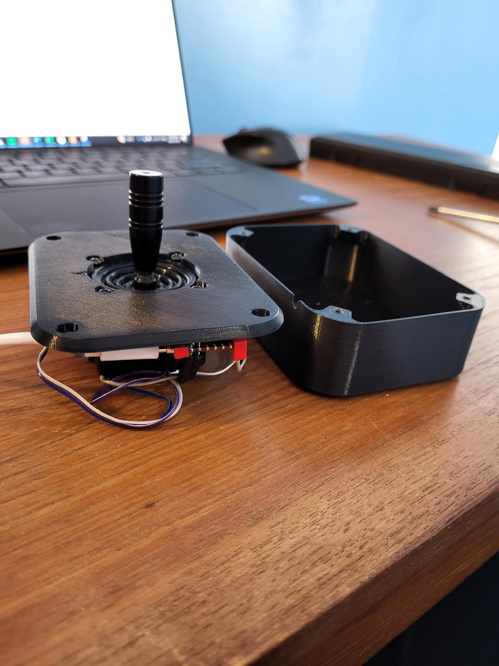

**Prototype 2**

Connect the walls to the top so the flat plate base now screw up into the top enclosure print. USB port widened for removability – change dependent on user testing feedback/preferences

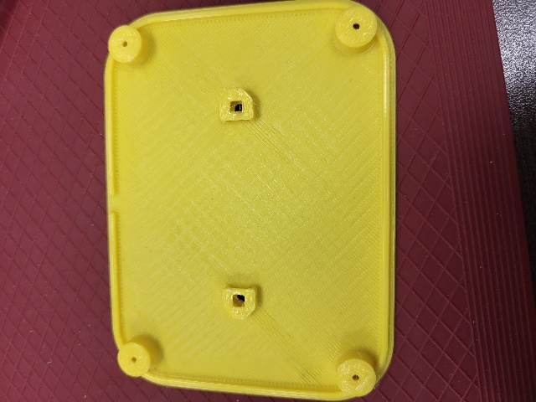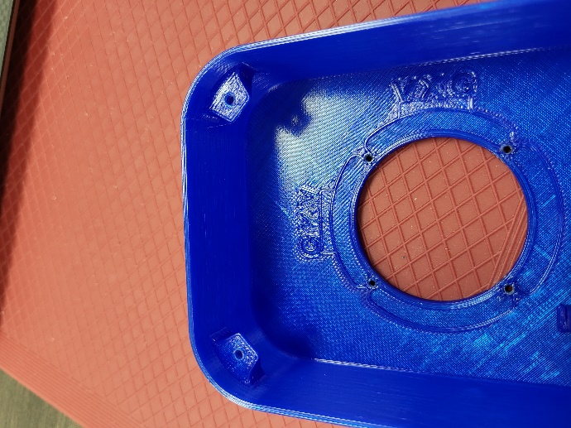

The design started with the walls being attached to the bottom and the top piece just being a plate, which was flipped (as seen in the above photos where the walls are attached to the top piece of the enclosure) so that the screws fastening the two pieces together were on the bottom and not the top. On the top, a screw sticking out could pose a risk to scratch the user and does not look as nice as a smooth, flat surface.

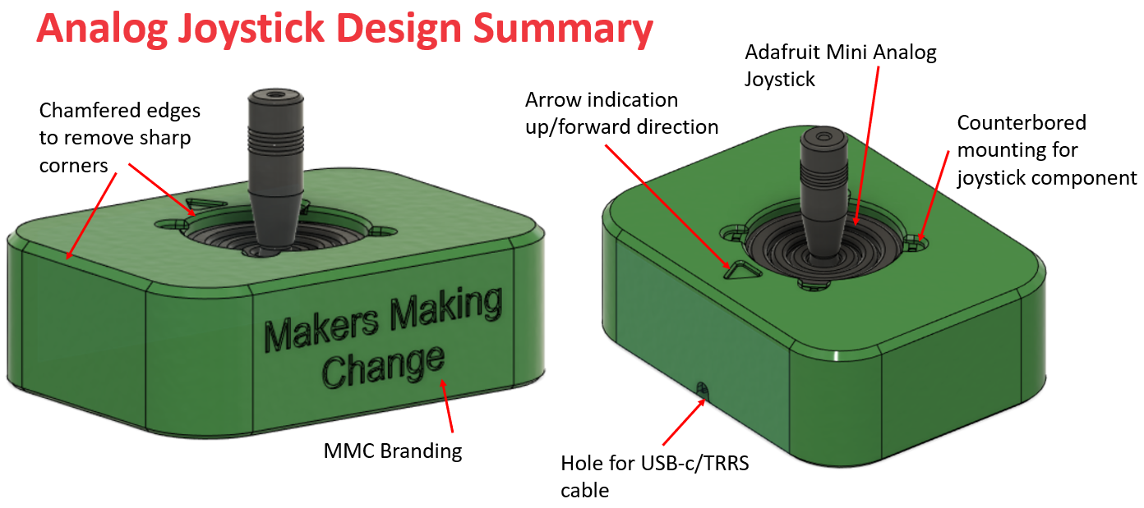

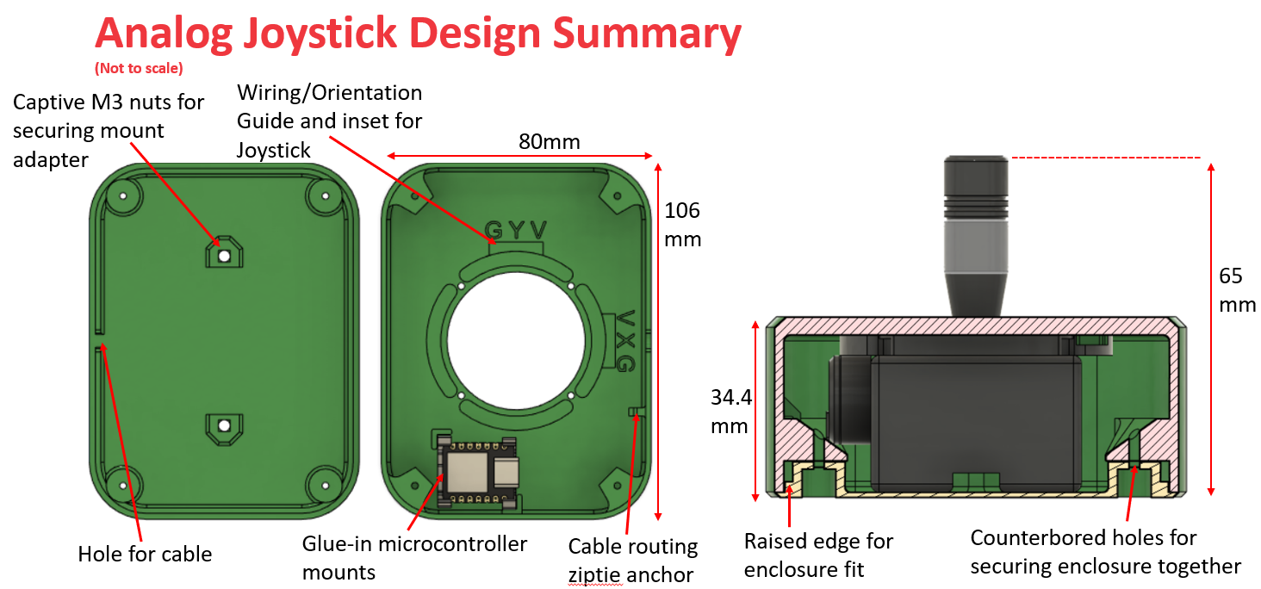

#### Toppers

Topper attachment: press fit – easiest to design and least material required. Also requires no extra hardware or tools for the maker or user.

Joystick shaft has a 12.232mm diameter in CAD model and 11.9mm from caliper measurement. Press fit diameter modelled to 12mm. Added an air-hole so not pocket of air is created. Added chamfers to edge of hole for easier alignment.

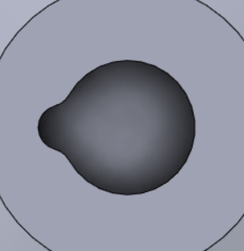

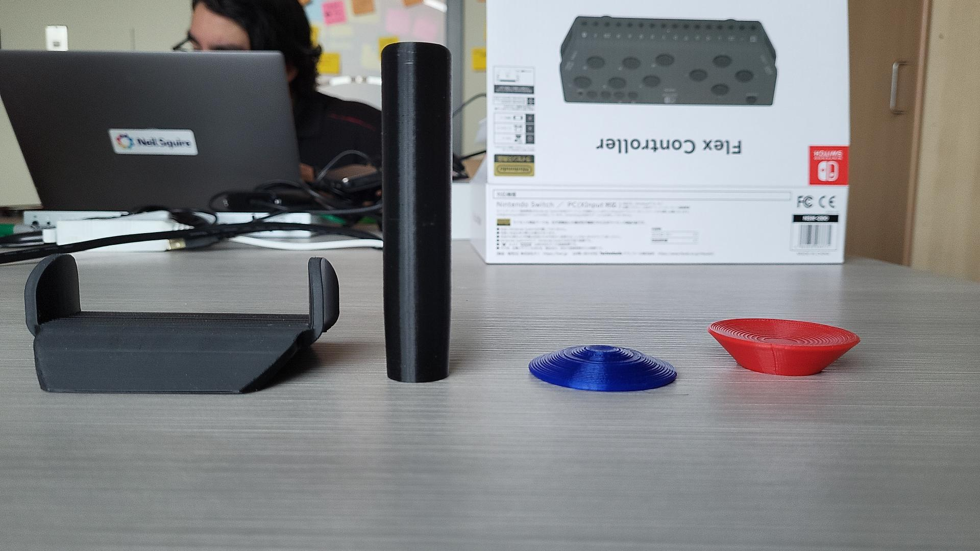

Remixed from [Microsoft Adaptive Accessories models](https://support.microsoft.com/en-us/topic/customize-your-microsoft-adaptive-accessories-with-3d-printed-designs-29ee6d7e-45f4-4730-bfe6-657c294d02ca)

<https://www.printables.com/model/110455-xac-joysticks-and-universal-adapter/files>

Goalpost Topper Cylindrical Topper Convex Topper Concave Topper

# Testing

PCB Mounting:

Glue-in snap fits: Current

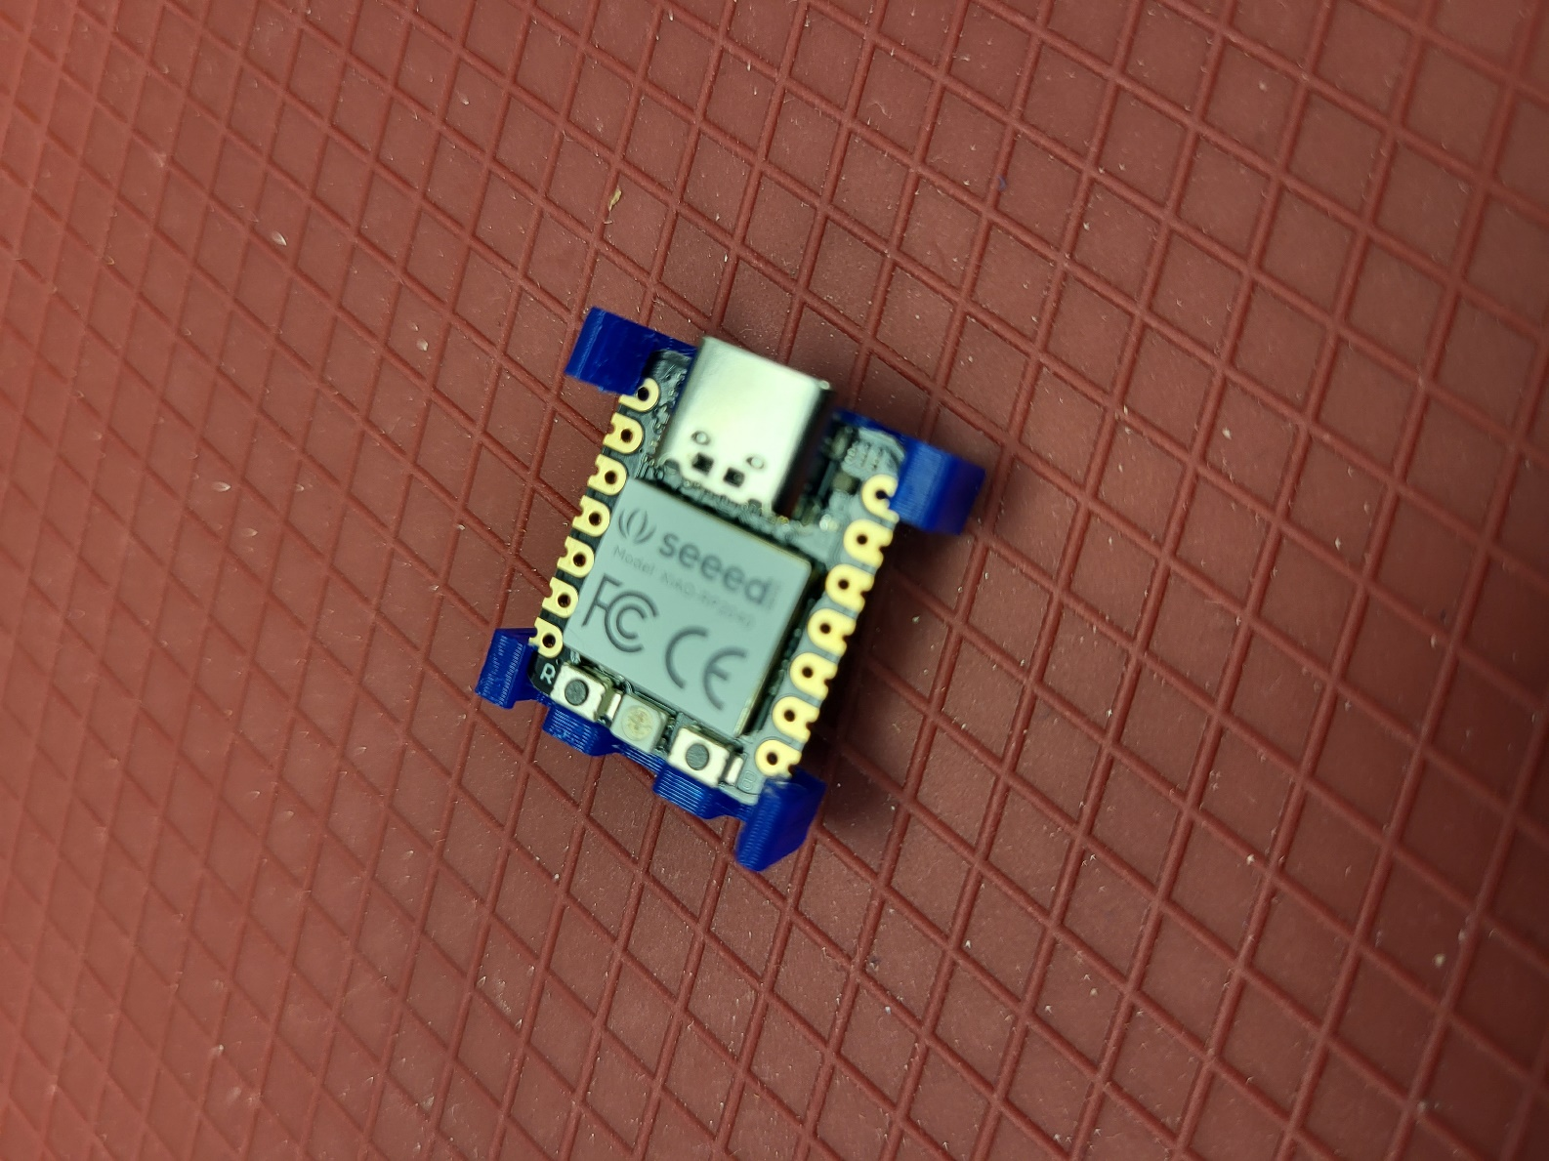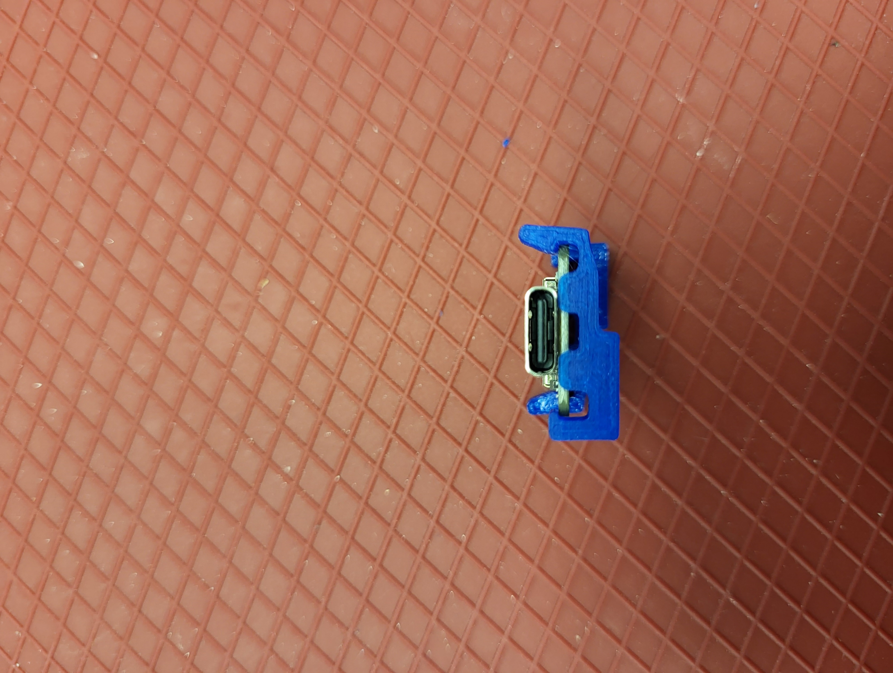

Built in slot: Needs a better retainment method (no extra prints)

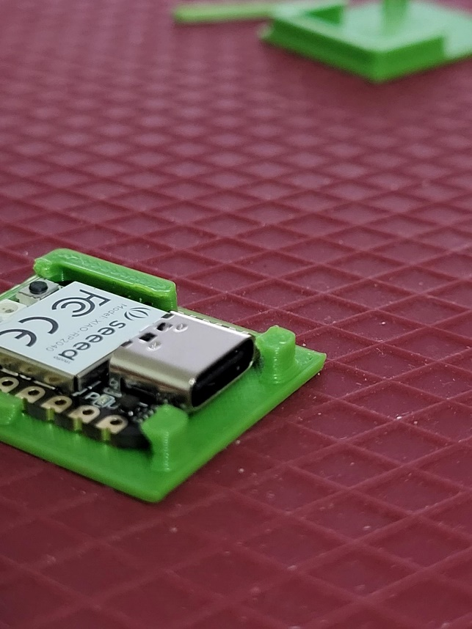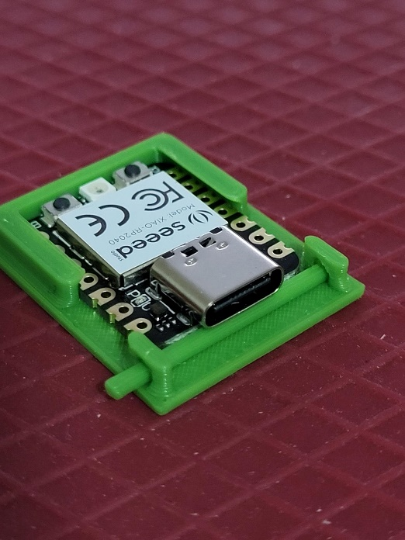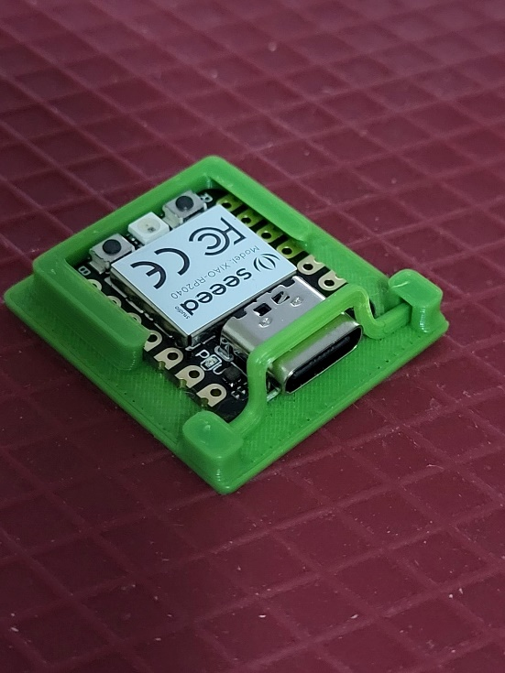

Screws (capturing with 3D print or just screws on the edges): Uses extra prints or fasteners

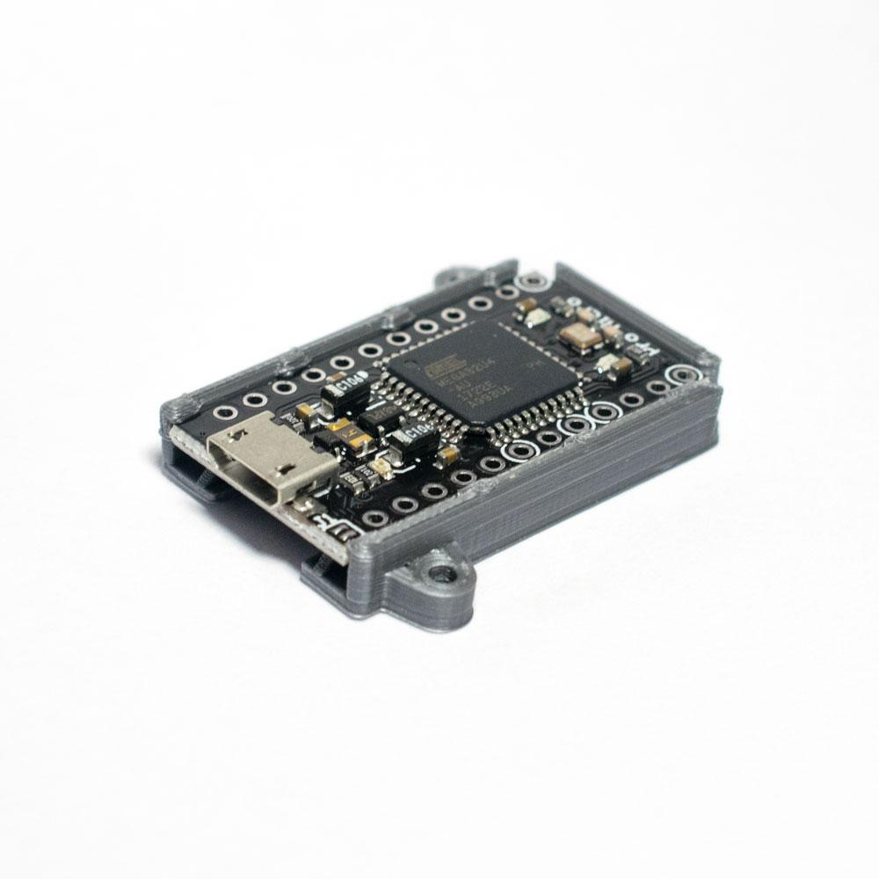

# Prototype v0.2 Design

Cable Routing: Added cable strain relief via rounded edges and a zip tie anchor for the cable.

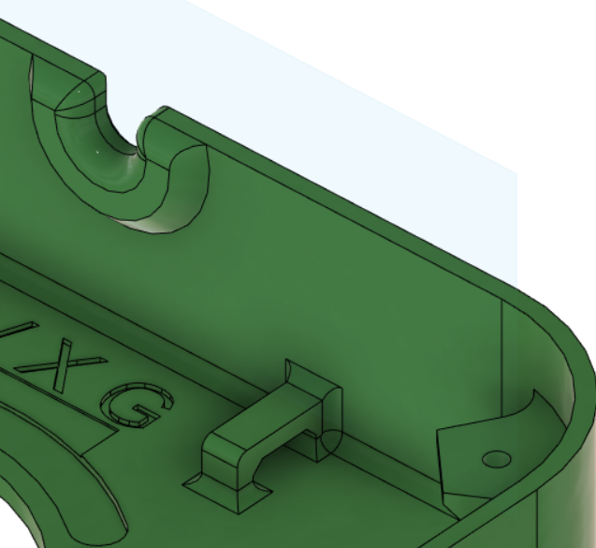

Top Surface: Chamfered all edges. Removed floating holes and replaced with chamfered holes as the screws are chamfered.

Split Line: Raised the split line so the bottom half of the enclosure has some more rigidity and meets the top enclosure piece better.

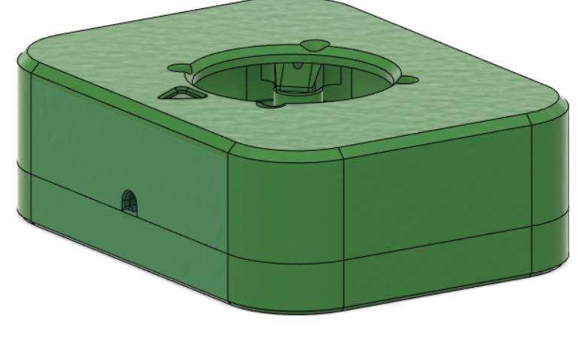

Bottom Enclosure: Added supports for rigidity connecting the holes in the bottom of the enclosure. Also added nut retainment to the slots for the optional camera mount adapter.

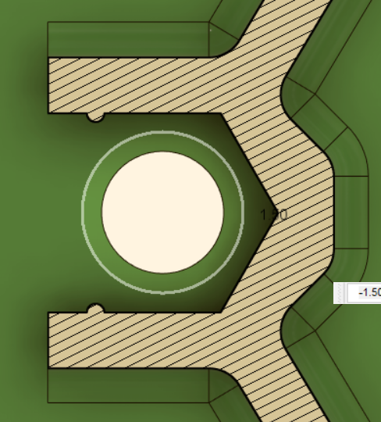 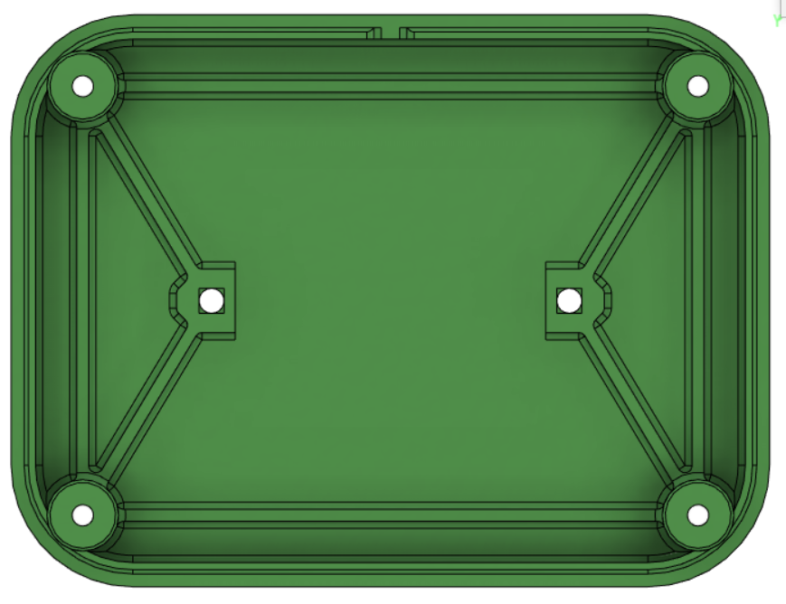

50mm

### Built Final Prototype

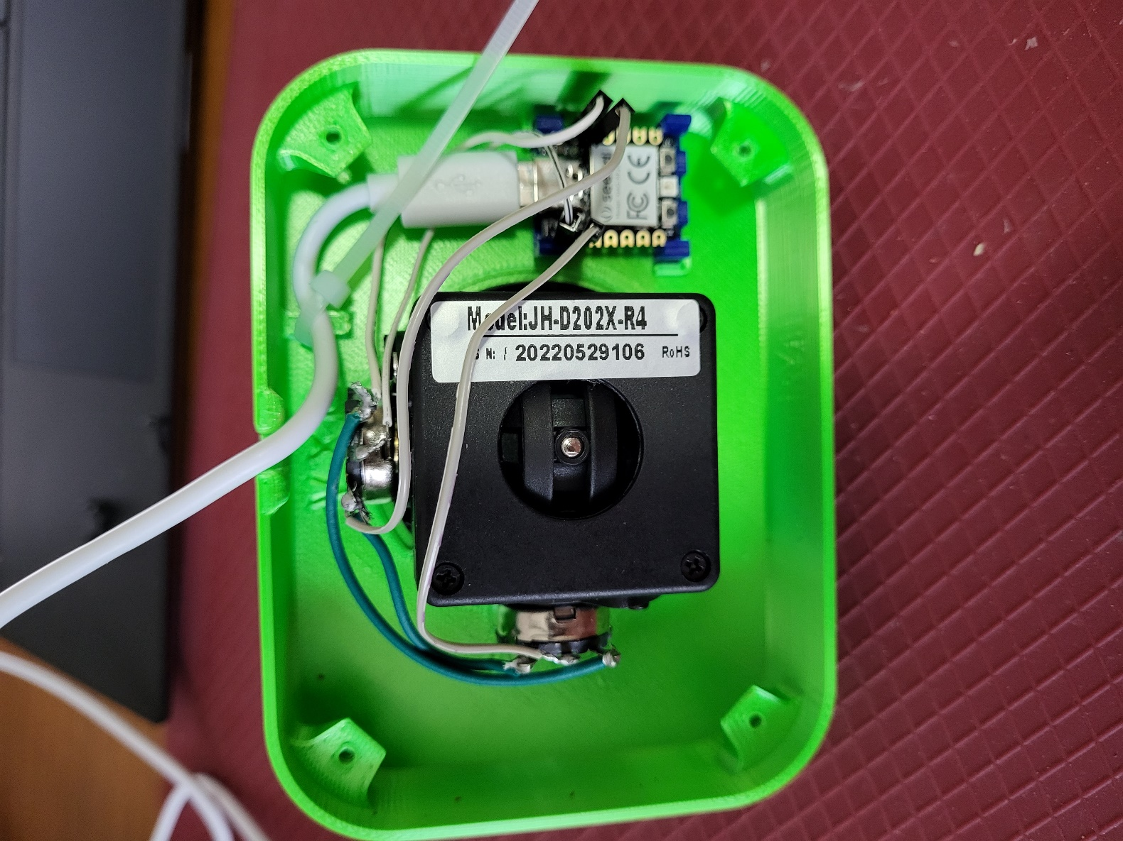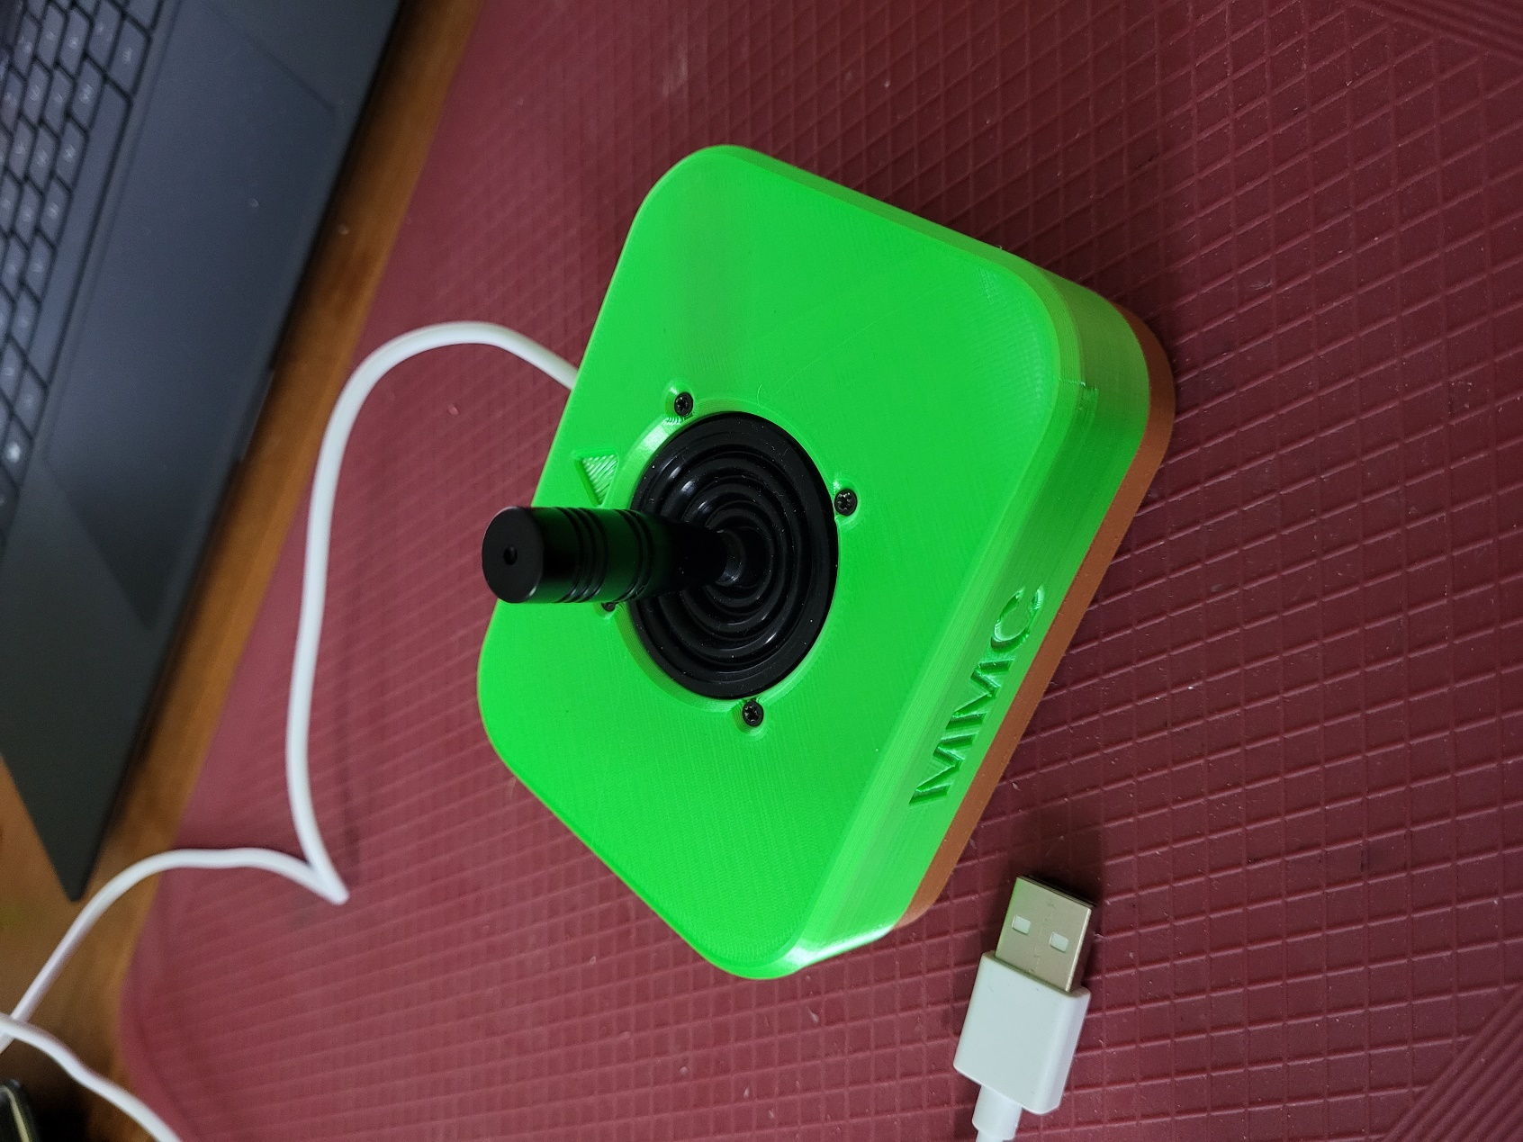

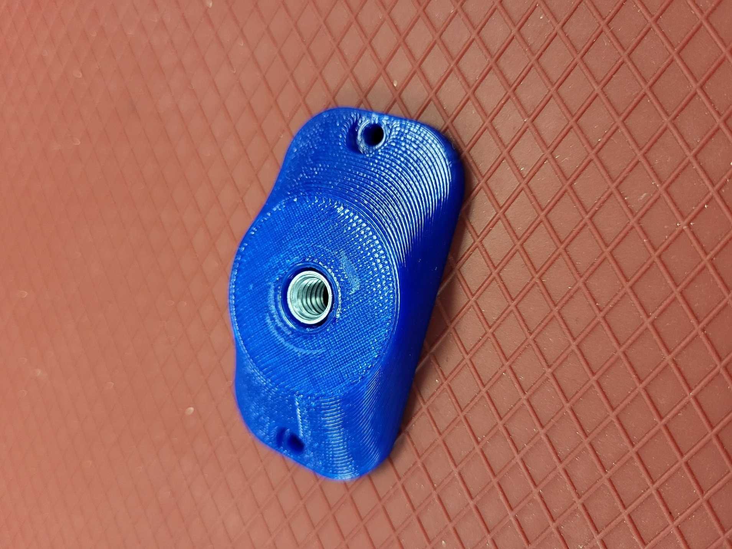

# Opportunities for Improvement

* Reduce to only requiring top and bottom enclosure print (no small extra prints for PCB mounting) – Would standardise the print between USB and TRRS versions.
* Customising the output/centering with potentiometer adjustment
* Versions with limited joystick throw (necessary with Ultrastik??)